

Practices for Secure Software Report

Table of Contents
Document Revision History 3
Client 3
Instructions 3
Developer 4
1. Algorithm Cipher 4
2. Certificate Generation 4
3. Deploy Cipher 5
4. Secure Communications 6
5. Secondary Testing 6
6. Functional Testing 7
7. Summary 8
8. Industry Standard Best Practices 9

Document Revision History

Version | Date | Author | Comments
1.0 | 10/18/2026 | Holton Kubosh | Initial Release

Client



Instructions

Submit this completed practices for secure software report. Replace the bracketed text with the relevant information. You must document your process for writing secure communications and refactoring code that complies with software security testing protocols.

- Respond to the steps outlined below and include your findings.
- Respond using your own words. You may also choose to include images or supporting materials. If you include them, make certain to insert them in all the relevant locations in the document.
- Refer to the Project Two Guidelines and Rubric for more detailed instructions about each section of the template.

Developer
Holton Kubosh

Algorithm Cipher

1. Algorithm Cipher
I recommend that Artemis Financial use the Advanced Encryption Standard (AES) with a 256-bit key to protect sensitive financial information. AES is a symmetric encryption algorithm, meaning the same secret key is used to encrypt and decrypt information. It was standardized by the National Institute of Standards and Technology (NIST) in 2001 and remains widely used because of its security, efficiency, and resistance to known practical attacks when implemented correctly. AES-256 provides strong protection for sensitive information, while an authenticated encryption mode such as Galois/Counter Mode (GCM) can also detect unauthorized modifications. Encryption keys should be generated using a cryptographically secure random number generator to prevent attackers from predicting them.
Asymmetric cryptography provides additional security by using separate public and private keys. For this project, I generated a self-signed certificate using RSA with a 3072-bit key and a SHA-256 digital signature. The certificate allows the application to establish an HTTPS connection using Transport Layer Security (TLS). Modern TLS connections use asymmetric cryptography to authenticate servers and establish shared secrets, while symmetric encryption protects information exchanged during the session. The specific encryption cipher is negotiated by the browser and server rather than explicitly configured in the application's code. Using symmetric and asymmetric cryptography together provides strong security without unnecessarily reducing application performance.
I also implemented SHA-256 to generate a checksum for a unique data string. SHA-256 is a cryptographic hashing algorithm that produces a fixed 256-bit output regardless of the original input length. Unlike encryption, hashing is a one-way process and cannot be reversed to recover the original information. The resulting checksum can be compared against a separately calculated hash to identify changes in data, provided the reference checksum is trusted. SHA-256 is preferable to older algorithms such as MD5 and SHA-1 because those algorithms have known collision vulnerabilities. Together, AES-256, RSA-based certificates, TLS, and SHA-256 provide complementary protections for confidentiality, authentication, and data integrity.

Certificate Generation
Insert a screenshot below of the CER file.

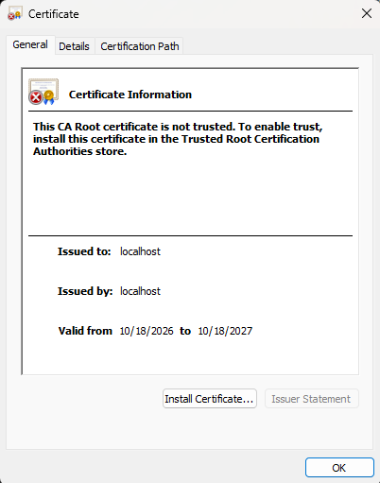
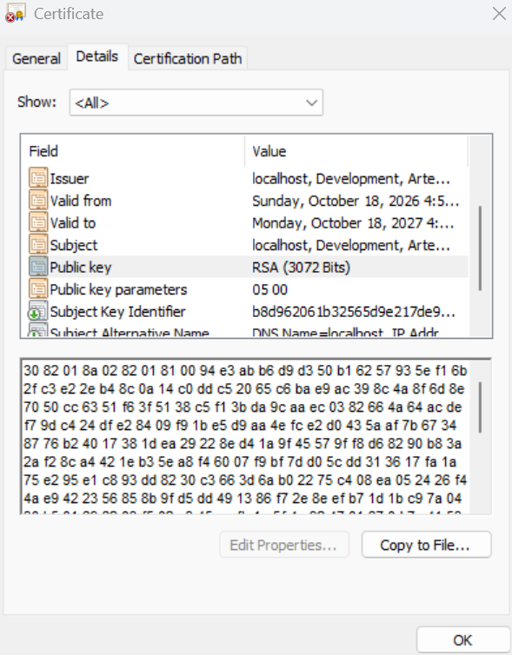

Deploy Cipher
Insert a screenshot below of the checksum verification.



Secure Communications
Insert a screenshot below of the web browser that shows a secure webpage.

Secondary Testing
Insert screenshots below of the refactored code executed without errors and the dependency-check report.

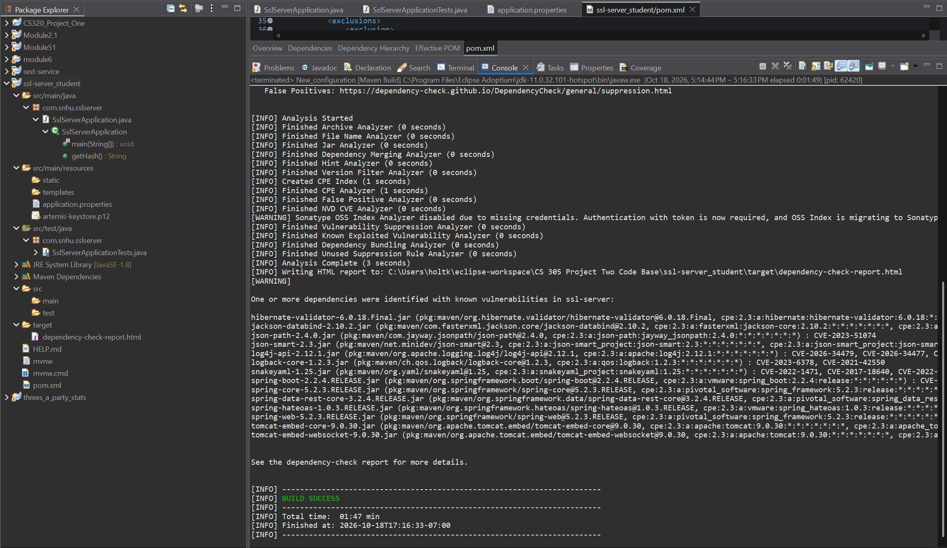
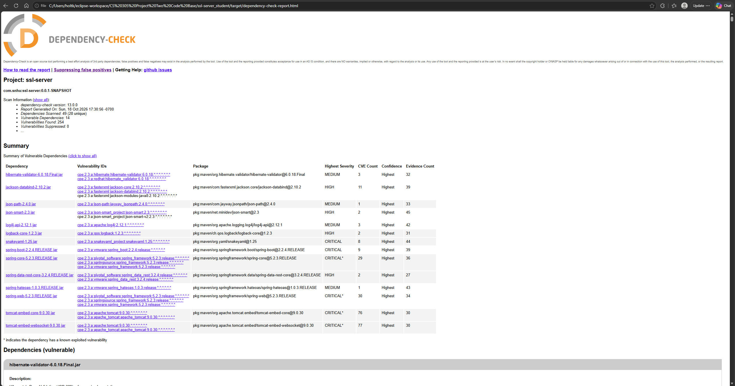

Functional Testing
Insert a screenshot below of the refactored code executed without errors.

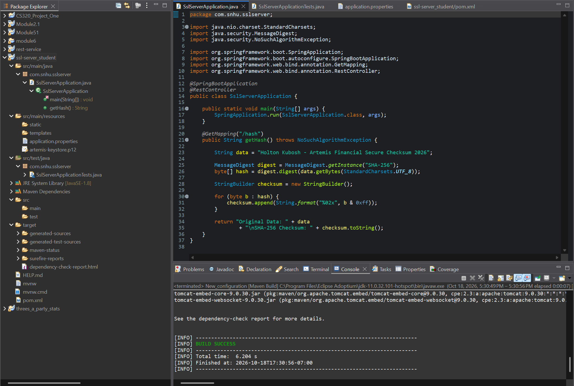
I manually reviewed the refactored Java code for syntax errors, logical issues, and potential security vulnerabilities. The application compiled successfully, and the SHA-256 implementation produced the expected checksum without accepting external user input. I also verified that the HTTPS configuration used the generated certificate and keystore. No obvious new vulnerabilities were identified in the modified code, although the dependency scan revealed known vulnerabilities in existing third-party libraries.

Summary

I refactored the Artemis Financial application to improve data integrity and secure communications. The original application did not have a functional checksum endpoint or a completed HTTPS configuration. I implemented SHA-256 hashing using Java's MessageDigest class to generate a 256-bit checksum from a unique data string. This allows the application to demonstrate how changes to data can be detected by comparing cryptographic hashes. I also generated a self-signed certificate using Java Keytool with a 3072-bit RSA key and configured the application to use HTTPS on port 8443. These changes help protect the confidentiality and integrity of information transmitted between the application and its users.
After implementing the security improvements, I performed functional and dependency testing to verify that the application continued to operate correctly. I confirmed that the application successfully established an HTTPS connection and returned the expected SHA-256 checksum through the /hash endpoint. I also ran Maven's automated tests, which completed successfully with one test executed and no failures or errors. Additionally, I used OWASP Dependency-Check to perform a secondary vulnerability assessment. The scan completed successfully but identified known vulnerabilities in several existing dependencies, including Spring Boot, Spring Framework, and Apache Tomcat. Since the refactoring did not introduce new application dependencies, these findings are associated with the original dependency versions rather than newly added libraries.
The refactoring demonstrates a defense-in-depth approach by combining secure communications, cryptographic hashing, certificate-based authentication mechanisms, and security testing. Each measure addresses a different security concern, reducing reliance on any single protection. Although the changes improved the application's security, the self-signed certificate is appropriate only for local development, and the outdated dependencies would need to be updated before production deployment. Continuing to perform dependency scans, functional testing, and manual code reviews would help identify vulnerabilities and maintain the application's security as it evolves.

Industry Standard Best Practices

Throughout the refactoring process, I applied industry-standard secure coding practices to improve the security of the Artemis Financial application. One of the most important practices was using established cryptographic algorithms rather than developing custom encryption or hashing methods. I implemented SHA-256 through Java's MessageDigest class to generate a consistent checksum for verifying data integrity. I also configured HTTPS using a self-signed certificate generated with Java Keytool, allowing the application to use TLS to encrypt communications between the server and client. Using established cryptographic standards helps reduce the risks associated with insecure algorithms and unprotected data transmission.
I also followed secure development practices by limiting changes to the functionality required by the project and testing the application after refactoring. The checksum endpoint uses a predefined data string, avoiding unnecessary user input and the potential vulnerabilities associated with improperly validated input. I performed functional testing to verify that the application compiled and operated correctly, and I used OWASP Dependency-Check to identify known vulnerabilities in third-party libraries. Although the scan identified several outdated dependencies, these findings demonstrate the importance of regularly reviewing and updating software components. For a production environment, additional improvements would include replacing the self-signed certificate with one issued by a trusted certificate authority, securely managing encryption keys and passwords, and updating vulnerable dependencies. These practices help reduce security risks while supporting the long-term reliability and maintainability of the application.

